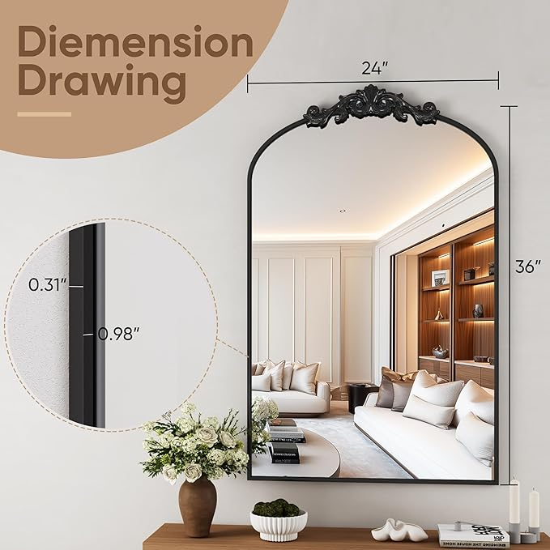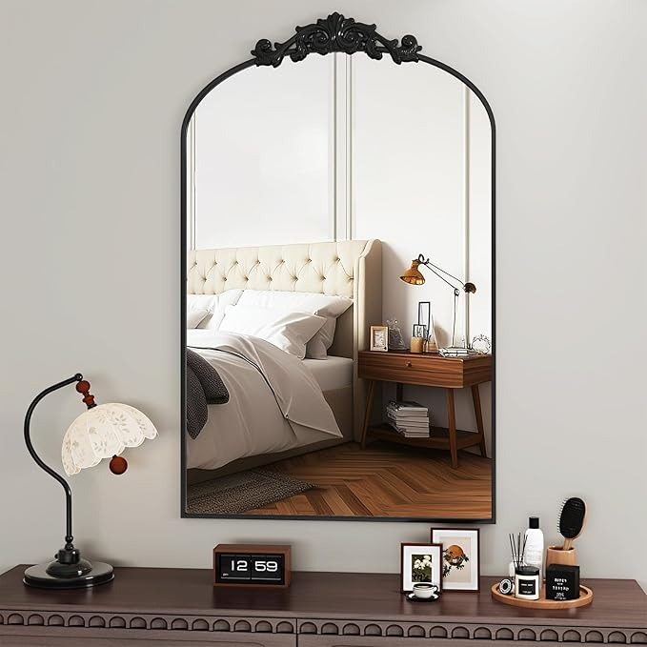

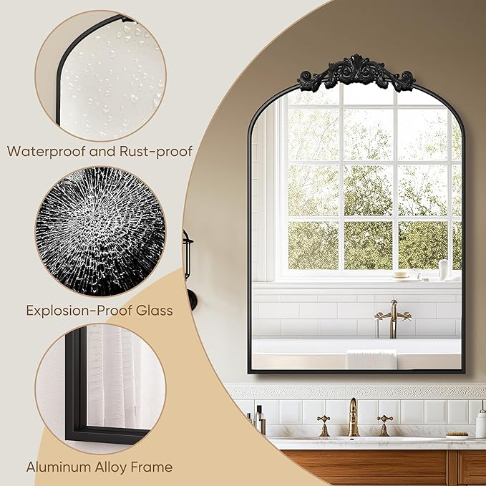

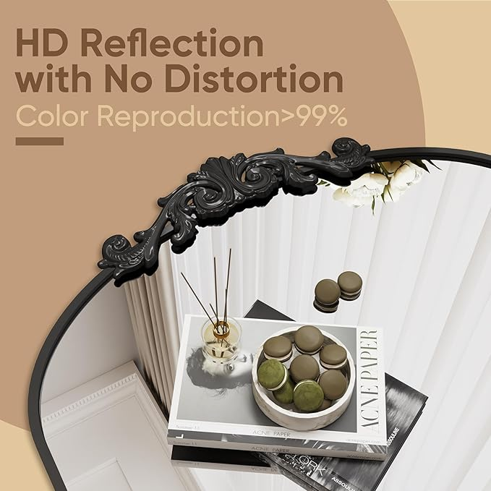

BEAUTYPEAK 24x36 Arched Mirror, Black Traditional Vintage Ornate Baroque Wall Mirror, Brass Mirror for Bathroom, Bedroom, Hallway, or Fireplace Decor

**PRODUCT DESCRIPTION:**

|  |  |
| --- | --- |
| **Brand** | BEAUTYPEAK |
| **Room Type** | Entrance Hall, Dressing Room, Bedroom, Living Room, Hallway |
| **Shape** | Arch |
| **Product Dimensions** | 36"L x 24"W |
| **Frame Material** | Aluminum |

**About this item**

* Elegant Vintage Arched Design: Featuring a sophisticated vintage design, this 36"X24" wall mirror's intricate detailing and classic finish effortlessly elevates any space, making it the perfect accent for an entryway, above a fireplace, in a bathroom, or next to a staircase
* Unique Artistic Decoration: The mirror's frame features a unique crown design with specially crafted decorative patterns, exuding an artistic flavor and visual appeal that not only enhances the mirror's aesthetic appeal, but also makes it stand out in any interior decor
* Durable Metal Construction: Featuring a sturdy metal frame that resists moisture and rust, this French vintage-inspired mirror combines durability with a unique texture. It will stand up to everyday use while adding a sophisticated touch to any room
* Safe and easy to install: the bathroom mirror comes with mounting accessories and brackets, super easy to install. In addition, we have completely upgraded the packaging of the mirror, with 4 layers of sturdy packaging to prevent the mirror from breaking, and plastic layer to avoid scratching the mirror
* Customer Service and Safe Packaging:Customer service is the center of our product philosophy, if the vintage ornate arched mirrors you receive are broken or defective, please contact us and provide us with a picture of the breakage, we will deal with it at the first time